Gravity Experiment!!
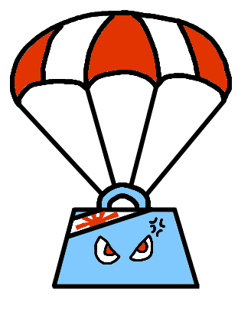
Task 1: Dropping things of different weight
- Take a piece of paper in one hand and a block of wood in the other.
  - Which is heavier?
  - Which do you think will fall faster and why?

- Roll the piece of paper up into tight ball and drop the two items from the same height at the same time.
  - Which landed on the ground first?
  - Why?

Task 2: Dropping things of the same weight but different size
- Using the ball of paper from the first task and grab a new piece of paper leaving it flat.
  - Do you think they will fall at the same speed?
  - Drop them from the same height at the same time. What happened this time?

  - Why?

Task 3: Dropping things on different parts of the Earth.

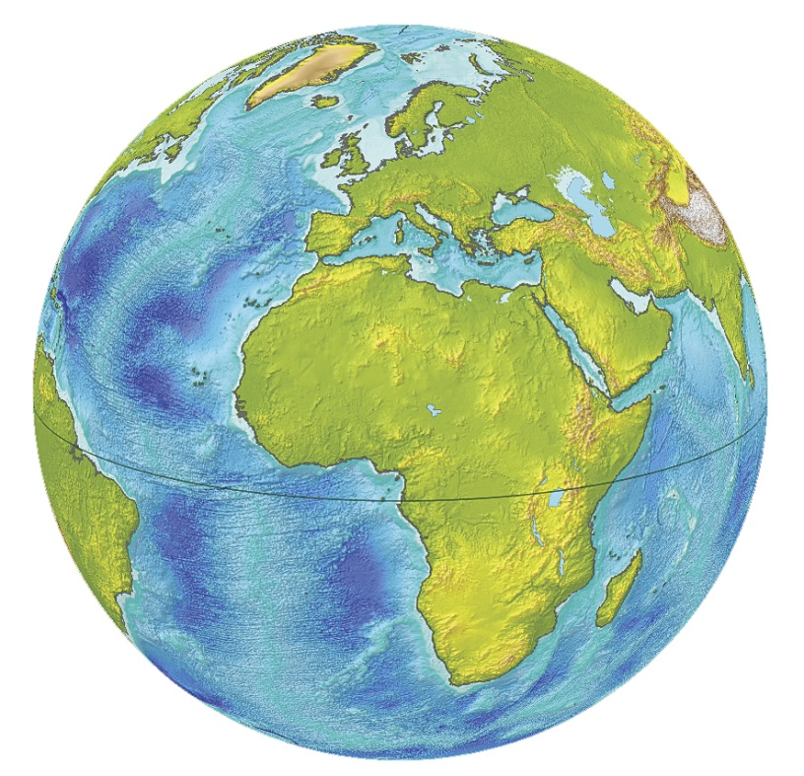

Draw a person on the top, bottom, left and right of Earth and show how gravity would affect them in these different positions.

Task 4: Your weight on different planets
Body | Gravity | Your Weight
Earth | 1
Moon | .16
Mercury | .37
Venus | .86
Mars | .38
Jupiter | 2.6
Saturn | 1.1
Uranus | 1
Neptune | 1.5

